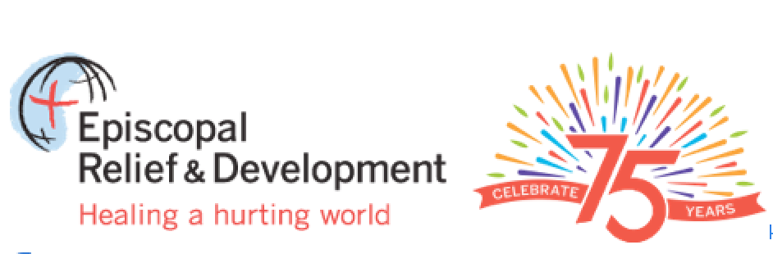
The Deacon’s Bench – What Do You Know about ERD?
Celebrate the 75th Anniversary of Episcopal Relief and Development and learn more about it by taking this “open-website” quiz. All of the answers to this quiz can be found by exploring the Episcopal Relief and Development website at www.episcopalrelief.org. Correct answers will be given in our April newsletter.
Names of those who complete the quiz with 100% accuracy will have their names published in our May newsletter and will have a donation made in their names to Episcopal Relief and Development the May newsletter.
The ERD Quiz
- At its founding in 1940, the organization we now know as Episcopal Relief and Development was called what? The Presiding Bishop’s Fund for World Relief.
- What was its primary mission at the time of its founding? To assist refugees fleeing Europe during World War II.
- ERD received its present name in 2000. Why? “Episcopal Relief & Development” emphasizes a growing programmatic focus on integrated community development. In 2003, the Board of Directors decided to shift from administering small grants for domestic and overseas projects to implementing sustainable programs and partnerships worldwide.
- Two years after Hurricane Mitch (2001) members of St. Peter’s helped build a new church in an Episcopal Relief and Development village in Honduras. More recently, we raised funds to help stop the spread of malaria in sub-Saharan Africa as part of another ERD project. Name either the village or the anti-malaria program. Village: Faith, Hope and Joy. Anti-Malaria Program: Nets for Life.
- ERD finds its mandate in the words of Jesus. Where can these words be found? Matthew 25:37-40. Extra points if you can give the scripture citation. “Lord, when was it that… We saw you hungry and gave you food? We saw you thirsty and gave you something to drink? We saw you a stranger and welcomed you? We saw you sick and took care of you? We saw you in prison and visited you? ‘Truly I tell you, just as you did it to one of the least of these who are members of my family, you did it to me.’
- Name ERD’s four core program areas. Alleviate hunger and improve food supply; Create economic opportunities and strengthen communities; Promote health and fight disease; Respond to disasters and rebuild communities.
- ERD works throughout the world, assisting the poorest of the poor. In how many countries is ERD active at the present time? Approximately 40 countries, worldwide.
- ERD is actively supporting long-term disaster recovery in three areas within the United States. It is presently assisting those affected by Hurricane Sandy. Name two other places where ERD supports long-term disaster recovery in the USA. Colorado, in response to floods in September, 2013; Oklahoma, in response to floods in April, 2013.
- What percent of each donor dollar goes directly to work in the field? 100%
- The “What You Can Do” tab on ERD’s website has how many drop downs? (8) Eight. What are they? Gifts for Life, Donate Now, Monthly Giving, Social Media Advocacy, Other Giving Opportunities, Act, Stay Informed, Careers.
- Episcopal Relief & Development offers Christian Formation programs for children, youth and families, and others, to support Episcopalians as they “continue in the apostles’ teaching and fellowship,” “proclaim by word and example the Good News of God in Christ” and “seek and serve Christ in all persons.” Name two of the programs offered: For Children: Abundant Life Garden Project, Rita Mosquito. For Youth: Act Out: Empowering Youth to Heal a Hurting World, Rita Mosquito. (Rita Mosquito is a malaria-prevention curriculum.)

- What is “Gifts for Life”? “Gifts for Life” is a program through which donors purchase gifts that provide concrete assistance to the poor in the areas of Animals and Agriculture, Basics for Life (Clean Water/Education), Health & Wellness, Economic Opportunity, and Green Gifts (reforestation, community gardens, rainwater harvesting, etc.) Name two other ways to support the work of ERD. Make a one-time donation. Schedule regular monthly donations. Make a Legacy, Honor, or Memorial Gift. Arrange for Corporate Matching of your gift. Give Stock & Securities. Participate in special giving programs available to Federal employees.
- Episcopal Relief and Development works on its own, never cooperating with other agencies. True or False? False. Through integrated community development and disaster relief efforts, ERD works directly with church and other partners to carry out its mission of empowering people to find lasting solutions to poverty, hunger and disease.

THE END. Please support God’s work through Episcopal Relief and Development.

